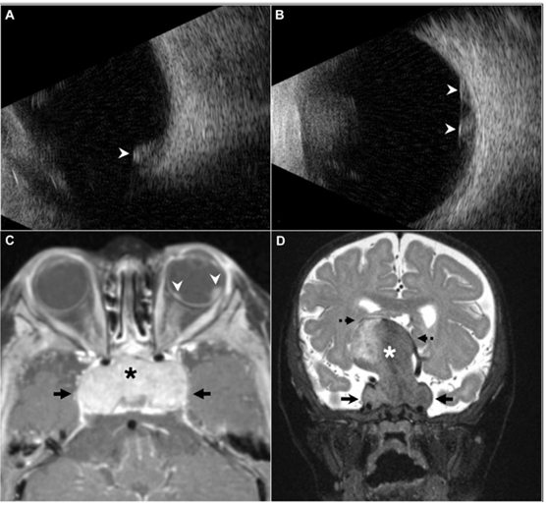

A 7-month-old girl with delayed milestones was referred. She lacked visual fixation. Ultrasonography confirmed hyperechoic intraocular tumors in her right (A, arrowhead)and left (B, arrowheads) eyes. Magnetic resonance imaging revealed bilateral multifocal RBs (C, arrowheads), and a large (46 37 41 mm)intrasellar/suprasellar mass (C and D, asterisk, arrows), compressing the lateral and third ventricles (D, dotted arrows), extending into thecavernous sinus (C and D, arrows). Based on the provided images and clinical description please make an ophthalmic diagnosis for this patient. And output the diagnostic conclusions only.

**Trilateral Retinoblastoma**